CIBL author template, instructions (delete this box before submission)
• Page length: 6000–8000 words (including Literature).
• Page setup: A4 (21 x 29.7 cm); margins 2.5 cm on all sides; one column.
• Font: Times New Roman throughout (incl. tables/figures).
• Spacing: single line spacing; do not add extra spacing before/after paragraphs.
• Main text: 12 pt, justified, first-line indent 1 cm.
• Abstract & Keywords: 10 pt, justified, first-line indent 1 cm; Abstract max 200 words; Keywords 3–5.
• Headings: major headings in UPPERCASE, bold, 12 pt, left aligned; do not number headings or subheadings.
• Tables/Figures: centered; table caption above table; figure caption below figure; include Source line if needed; cite each table/figure in text.
• Citations: in-text citations in the form (Surname, year) or Surname (year).
• References: numbered list in APA 7th style (10 pt).
• Avoid hard tabs; use styles. Do not add page numbers, headers/footers, or footnotes.

tITLE OF the ARTICLE
Author names, surnames, ORCID, Email address¹
Author names, surnames, ORCID, Email address²
Institution, Department, Country¹
Institution, Department, Country²

Abstract
Abstract is way to briefly present theories analyzed, research methods selected and the aim, also main research results. The length of the abstract is no more than 200 words (first line indent 1 cm., no space, 10 pt, Times New Roman, alignment of both sides).

Keywords: 3-5 keywords

INTRODUCTION
This template will assist you in formatting your paper. Please, insert the text keeping the format and styles. The main parts of the article are introduction, theory analysis, research methodology, research data analysis, acknowledgements (if applicable) conclusions, literature. References in the text are indicated by the author's name and the year of publication:
1. Text text text text .......... (Surname, year);
2. Surname (year) text text text text text ...... .
The final paper length should be between 6000 to 8000 words (including literature). All pages’ size should be A4 (21 x 29,7cm). The top, bottom, right, and left margins should be 2,5 cm. All the text must be in one column and Times New Roman font, including figures and tables, with single-spaced.
The main parts of the introduction (their titles bold):
Research topicality and problem. It is necessary to substantiate why it is important to perform such research, to indicate the problem of the research, to demonstrate the level of its scientific research. The relevance of the topic must be based on the scientific literature.
The aim of the research. The aim (one) of the study should be formulated. If the author thinks it is necessary to submit research tasks, then they should be presented them in the usual form as indicated (without numbering, in a sequential text).
The research methodology. The methods of data collection and analysis of the research are briefly presented, the research sample and other information that the author thinks as necessary are presented.
The research results. The main and essential results of the study are presented briefly without any details.
Originality/Value of the article. The author explains how valuable the research is, how original it is and what distinguishes it from other research of a similar nature, how valuable and useful the results are, the expected assumptions and possibilities for the continuity of the research should also be presented.

LITERATURE REVIEW
In the literature review section, authors will discuss theories and key research relevant to their study

RESEARCH METHODOLOGY
In the research methodology section, the author (s) substantiates the research strategy, explains the research data collection and analysis methods and their selection for particular research, describes the research sample and justifies its selection, explains the research tools/instruments used, presents the research process and stages, research ethics. Other necessary information may also be provided.

RESEARCH RESULTS AND DATA ANALYSIS
If the text is presented in the sections and subsections, it must begin with a section or subsection title. Do not use hard tabs and limit the use of hard returns to one return at the end of a paragraph.

Subsection
Please, do not number to the sections and subsections. Present tables and figures as shown below, give links to tables and figures in the text (1 table/1 fig.):
1 table. Table title
Column title (Heading 1) | Column title (Heading 2) | Column title (Heading 3)
Text (Times New Roman, 10 pt, usually sentence case)
Source: as in literature

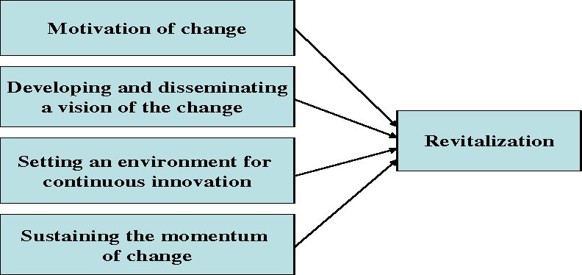
1 fig. Figure title (12 pt, Times New Roman, centred, sentence case, no space)
Source: as in literature (10pt, Times New Roman, centred, sentence case, no space)

Tables and figures should be centred and are numbered independently, in the sequence in which you refer to them in the text. Use the abbreviation “1 fig.”, even at the beginning of a sentence. Figure captions should be below figures and graphics should be accompanied by a legend; table heads should appear above tables.
Define abbreviations and acronyms the first time they are used in the text (if any), even after they have been defined in the abstract. Do not use abbreviations in the title or heads unless they are unavoidable. Please, do not add any kind of pagination anywhere in the paper. Avoid using headers and footnotes.

DISCUSSION
In this section, authors will interpretate their results via theoretical lenses that relevant to this study. The results will be compared with the previous studies.

CONCLUSIONS
Conclusions must be numbered, conclusions must present information according to the completed research (theoretical basis and empirical results).
- Text text text …………
- Text text text …………

ACKNOWLEDGEMENTS
Optional statement to thank other contributors, assistance, or financial support.

Literature
References should be cited according to the Bibliography and APA Citation Style, numbered in sequence – 7th edition (https://apastyle.apa.org/style-grammar-guidelines/references/examples). Examples:
- Grady, J. S., Her, M., Moreno, G., Perez, C., & Yelinek, J. (2019). Emotions in storybooks: A comparison of storybooks that represent ethnic and racial groups in the United States. Psychology of Popular Media Culture, 8(3), 207–217. https://doi.org/10.1037/ppm0000185
- Jackson, L. M. (2019). The psychology of prejudice: From attitudes to social action (2nd ed.). American Psychological Association. https://doi.org/10.1037/0000168-000
- National Cancer Institute. (2019). Taking time: Support for people with cancer (NIH Publication No. 18-2059). U.S. Department of Health and Human Services, National Institutes of Health. https://www.cancer.gov/publications/patient-education/takingtime.pdf
- …

